

**GEOG3028 Environmental Modelling**

Professor Simon Gosling

**Practical: Running climate change simulations with the MAGICC reduced complexity climate model**



**Introduction**

MAGICC stands for 'Model for the Assessment of Greenhouse Gas Induced Climate Change'. It is a **reduced-complexity model**, which means it is different from an Earth System Model (ESM) or Global Climate Model (GCM), which are much more complex.

A nice feature of reduced-complexity models is that they can be run very quickly, on PCs, often within hours or days, and even in seconds (as we will see in this practical). On the other hand, ESMs and GCMs can take months to run, even when using one of the world’s fastest supercomputers.

The tradeoff for improved speed with using reduced-complexity models is that they provide less detailed information than ESMs and GCMs, e.g. they typically only simulate a few variables, like temperature, and they tend to output large-scale spatial averages, like global averages. On the other hand, ESMs and GCMs can produce simulations for hundreds of climate variables on fine grids covering the entire globe (e.g. every 50km).

MAGICC has been designed, using the latest science and environmental modelling techniques, to enable rapid assessment of the effects on the global climate of different greenhouse gas emission amounts. MAGICC is a contemporary state-of-the-art research grade climate model that is used to support international climate policy decision-making. For example, it is often used by the United Nations Intergovernmental Panel on Climate Change (IPCC) and it has been used in several important journal publications, e.g. Meinshausen et al. (2022), which is a paper published in Nature that showed how global warming could be kept to below 2°C above pre-industrial temperatures if the pledges made as part of the 2015 Paris Agreement are seen through.

MAGICC is sometimes described as “Earth’s climate in a nutshell” (which is where the logo above comes from), because the model focuses on simulating the main features of the global climate (principally global mean temperature) and how it responds to changes in greenhouse gas concentrations.

In this practical we will use the MAGICC reduced-complexity model to do three things:

1. Simulate global average temperature for the future, up to the end of the century, for **two different scenarios of future greenhouse gas emissions**.
2. Explore what effect model choices can have on the simulated results, namely **changing the number of layers that are used in the model to represent the ocean**.
3. Simulate the effect of volcanic eruptions on the climate, separately for **large volcanic eruptions** such as those seen in recent centuries, and for a **super-volcano eruption** like what happened 74,000 years ago.
4. **Register with MAGICC**

* Go to the MAGICC website: <https://live.magicc.org/>
* If you have not already done so previously, create a free account by clicking on “Sign up” at the top right of the page.
* Use your University email address to register and create a password, then click next.



* Proceed through the following pages to register. If you are asked to provide “the name of your team”, you can leave this section blank.

1. **Login to MAGICC**

* Go to <https://live.magicc.org/> and Login using the email address and password you registered with.
* After you login, you will be on the **Scenarios Dashboard** of MAGICC. This is the main page of MAGICC and it shows the climate model simulations that you have run previously. It is also where you can create new scenarios to run with the climate model.

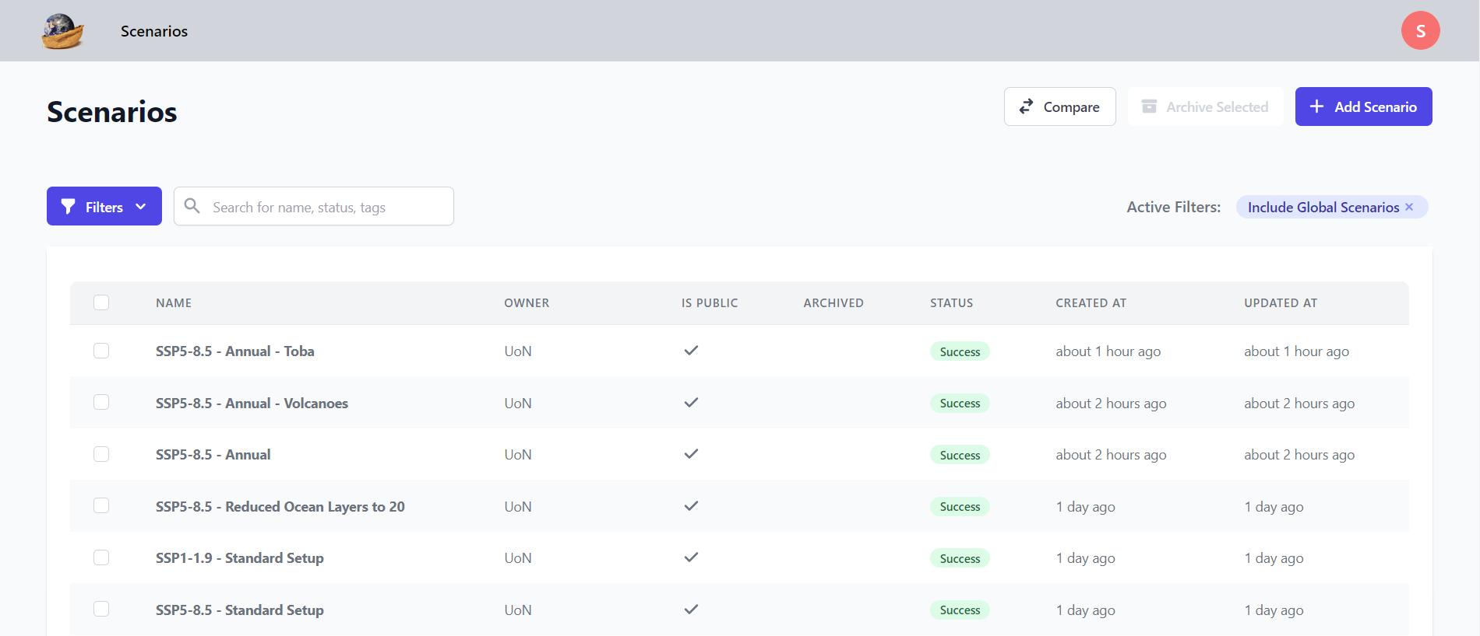

1. **Run two future climate change scenarios with the climate model**

* The first simulations we are going to do in the practical are climate model simulations for the future.
* We will run two simulations, with each simulation making different assumptions about future greenhouse gas emissions.
* All models require input data to run, whether they are hydrological models, health models or climate models.
* The input data most commonly used as input to climate models is information on greenhouse gas emissions. The greenhouse gases are a type of climate **forcing**, like we said in one of the lectures.
* We will use two different **emissions scenarios** as input datasets for our two respective simulations.
* The first scenario has **high greenhouse gas emissions** in the future, which is typical of a world there is no climate action, e.g. limited or no climate policy to reduce global emissions of greenhouse gases. This scenario is called “**SSP5-8.5**”.
* The second scenario we will use is for a world where there is **strong climate action**, which is in line with the 2015 United Nations Paris Agreement. This scenario is called “**SSP1-1.9**”. It is a **low emissions scenario**.
* We will run the two scenarios separately and after we have done the simulations we will compare them.

***First we will run the high emissions scenario (SSP5-8.5)***

* On the **Scenarios Dashboard**, click on “Add Scenario”:



* This will take you to the **Create New Scenario** page, which should look like this:

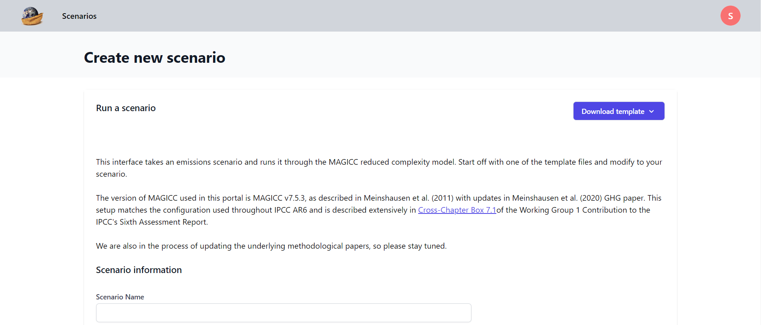

* It is here where we tell the climate model what input data it needs to run, i.e. what greenhouse gas emissions.
* When running any kind of model, the input data needs to be provided in a specific format. It is possible to download a template file, which shows you what the input data format needs to be for MAGICC.
* Download the template for the SSP5-8.5 scenario by clicking on “Download template” and selecting “SSP5-8.5” from the menu:

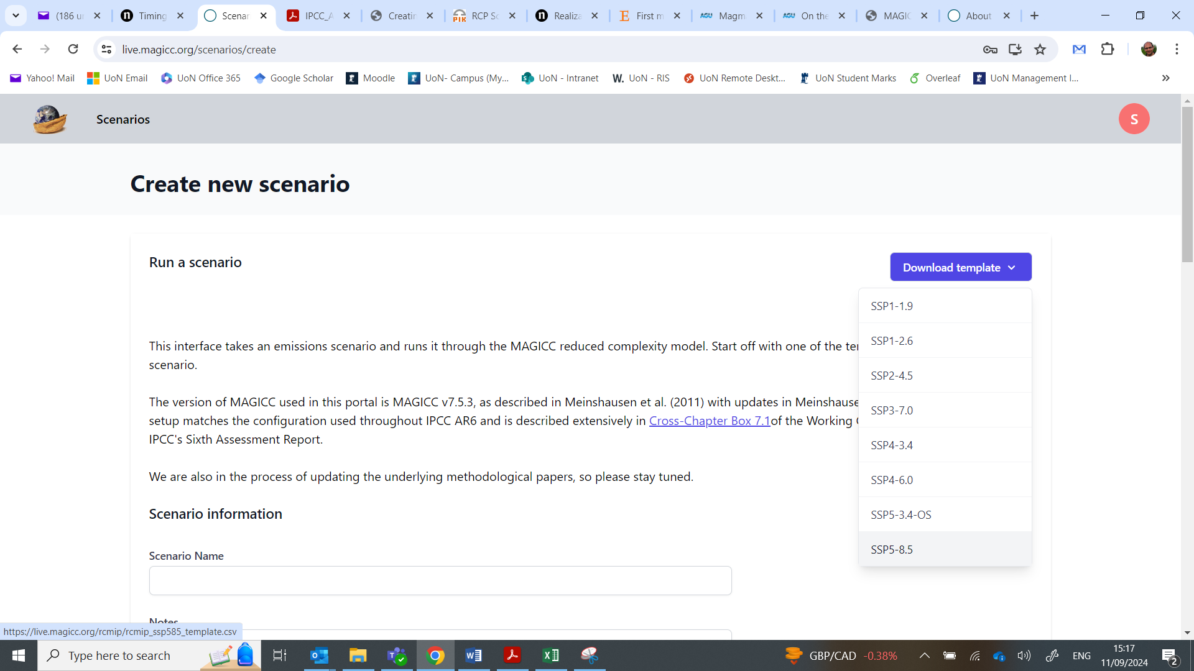

* This will download a file called “rcmip_ssp585_template.csv”. This is the template input file that we will use to run the climate model.
* Create a folder somewhere on your computer called **TEMPLATES** and copy the file you just downloaded to this folder.
* Rename the file “**SSP5-8.5_templ**”.
* Open the file by double-clicking on it (it should open in Excel).
* The file should look like this. You can make the columns wider in Excel to see what is in each cell. If the file does not like this then you have probably downloaded the wrong template:

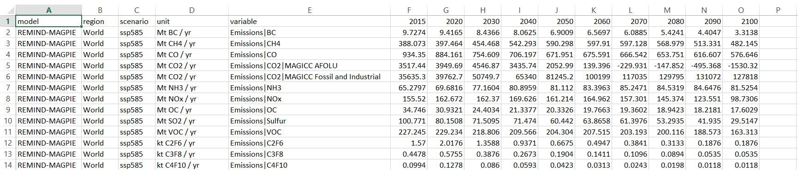

* You will see that the file includes information on multiple greenhouse gas emissions (the different rows) for different time periods (the columns). There is data for the following greenhouse gas emissions, which the climate model will use to simulate the climate:
  + Fossil / industrial carbon dioxide (CO2) emissions in units GtC/yr.
  + Landuse carbon dioxide (CO2) emissions in units GtC/yr.
  + Methane (CH4) emissions in units MtCH4/yr.
  + Nitrous oxide (N2O) emissions in units MtN/yr.
  + Sulphate dioxide (SO2) emissions in units MtS/yr.
  + Carbon monoxide (CO) emissions in units MtCO/yr.
  + Non-Methane Volatile Organic compounds (NMVOC) in units Mt/yr.
  + Nitrogen Oxides (NOx) in units MtN/yr.
  + Black Carbon (BC) in units Mt/yr.
  + Organic Carbon (OC) in units Mt/yr.
  + Ammonium (NH3) in MtN/yr.
  + Perfluorocarbons (PFCs) in the units kt/yr, namely CF4, C2F6, C6F14.
  + Hydrofluorocarbons (HFCs) in the units kt/yr, namely HFC23, HFC32, HFC43-10, HFC125, HFC134a, HFC143a, HFC227ea, HFC245fa.
  + Sulfur hexafluoride (SF6) in units kt/yr.
* Use Excel to plot a graph of fossil and industrial CO2 emissions so that you can visualise how one of the greenhouse gases changes in the future for this high emissions scenario. This is best done with the scatter plot function in Excel. The graph should look something similar to this:

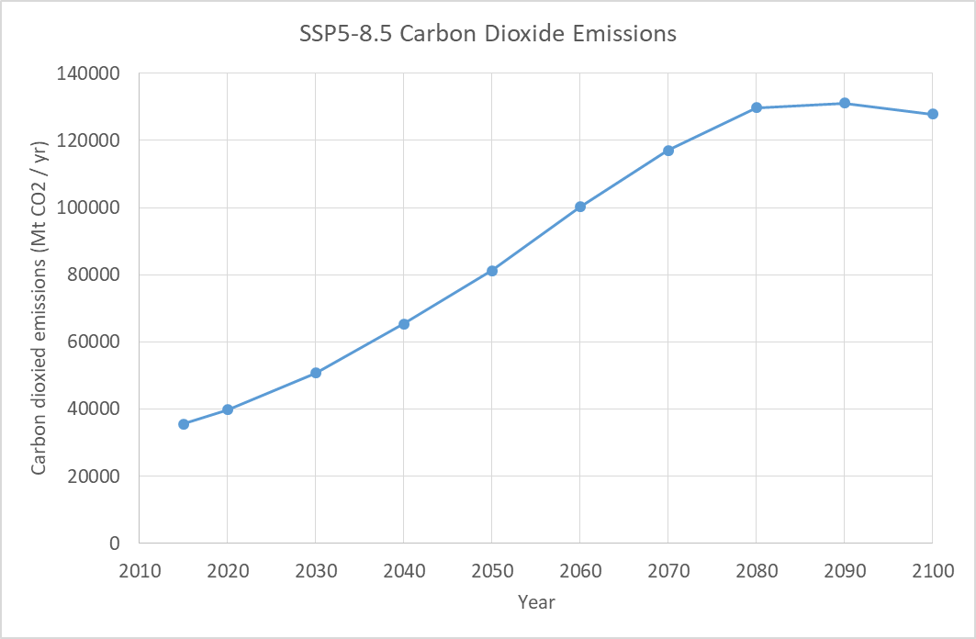

* We will now run the climate model with the input data for high greenhouse gas emissions (SSP5-8.5).
* On the **Create New Scenario** pageofMAGICC, type “SSP5-8.5 - Standard Setup” into the box below “Scenario Name”, like this:

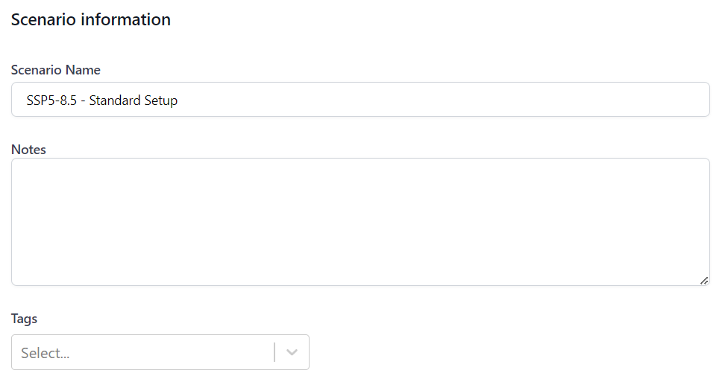

* You can leave the boxes next to “Notes” and “Tags” blank. These boxes are just there in case you do lots of simulations and want to create a record of what you have done in each one in case you come back to them in the future.
* Scroll down the page to where you see the “Emissions” section. This is where we will tell the climate model what input data it should use to perform its climate simulation:

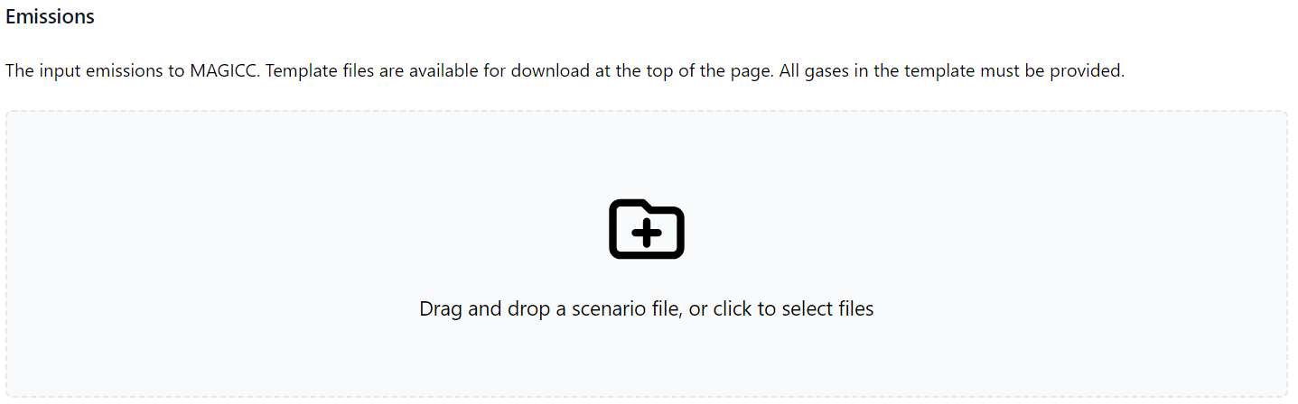

* Click on the folder icon with the plus sign in it.
* A window will open, prompting you to select a file. Navigate to the folder called TEMPLATES where you saved the SSP5-8.5 file. Click on the file and then “Open”.
* Scroll down to the section of the **Create New Scenario** pageofMAGICC where you see “MAGICC Setup”. This is where you can alter some of the features of the climate model, like how many layers the ocean in the model has.
* In the MAGICC Setup box, select “**Custom**” from the drop-down menu:

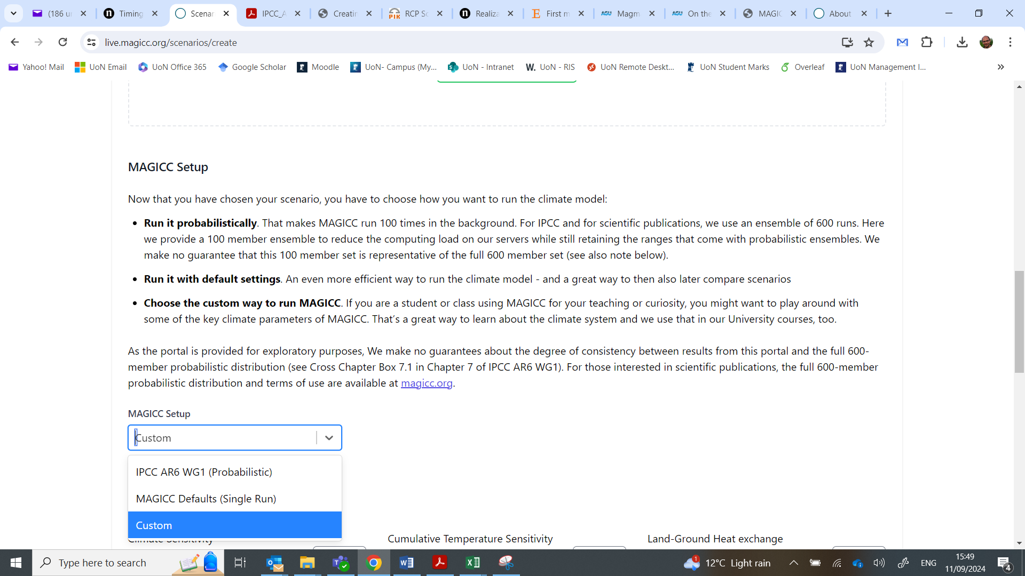

* This will make available a series of model options that can be changed with sliders or by inputting numbers into a box:

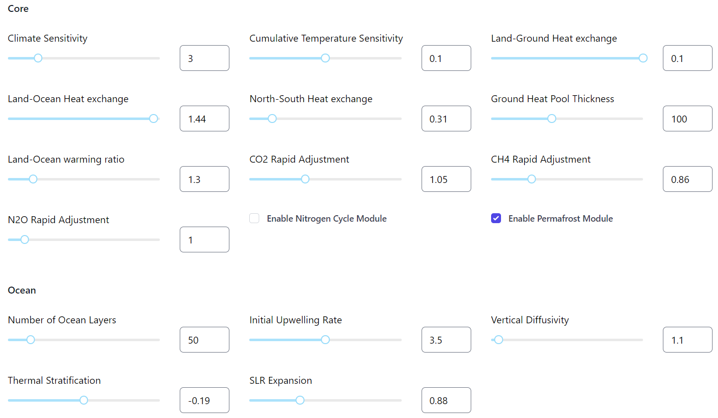

* Don’t change any of the model settings, but have a look at the different options that can be changed. Later on in the practical we will change one of the settings.
* Click on “**Run scenario**” at the bottom of the page to run the climate model:



* The climate model will now start running the SSP5-8.5 scenario. The model should take around 20 seconds to run, during which time the page will look like this:

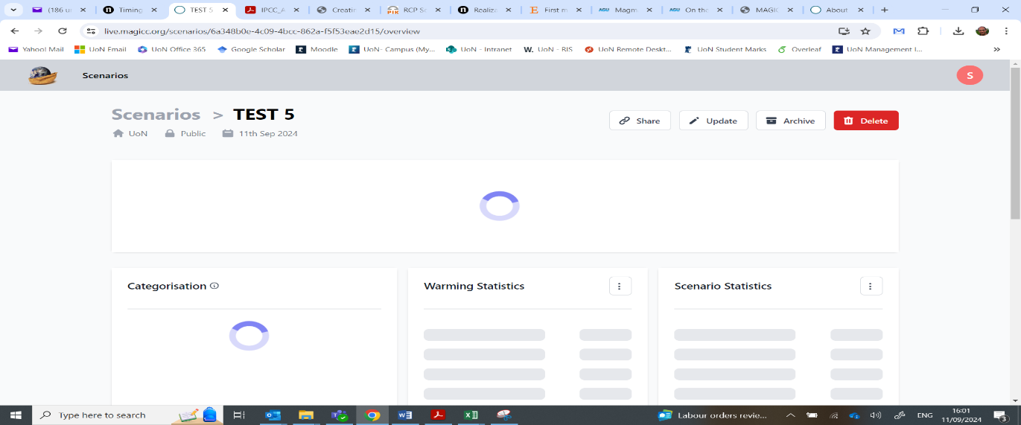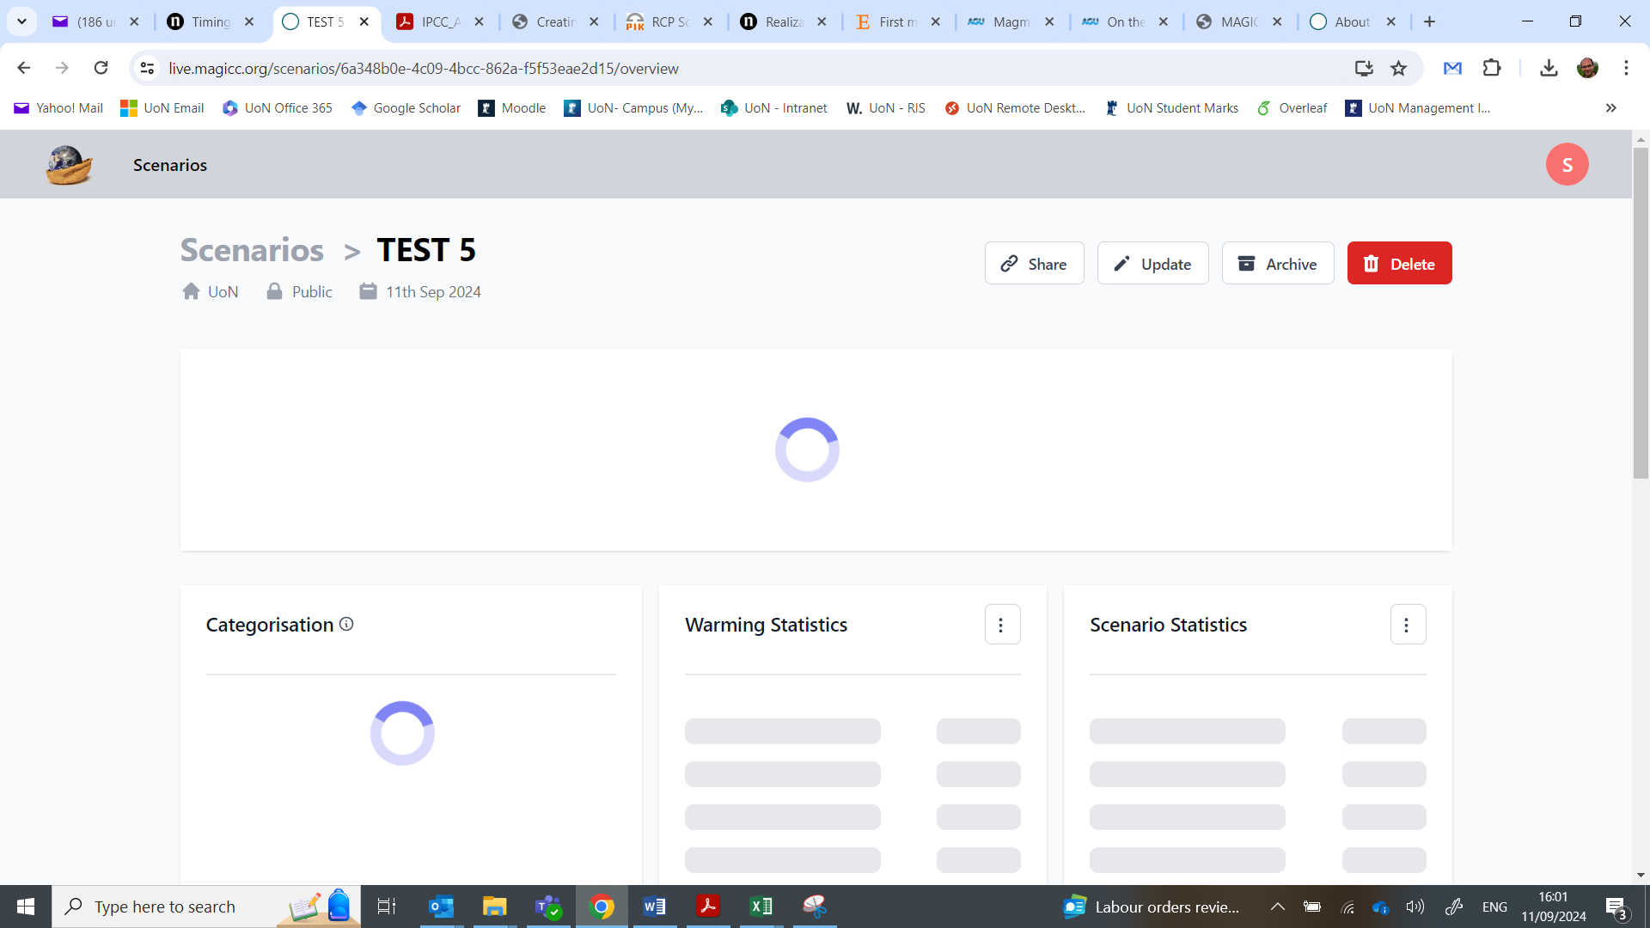

* When the model has finished running, it should look like this:

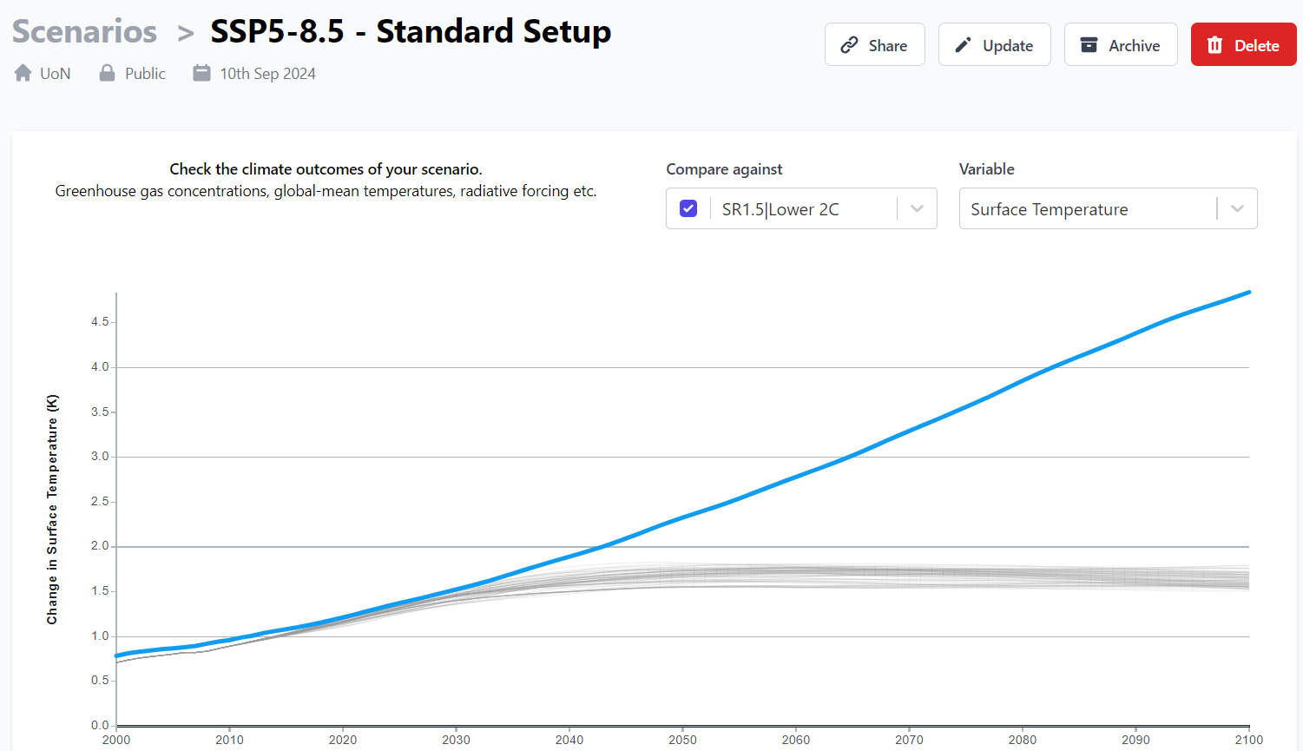

* The graph is interactive, so you can change what it is plotting. As a default, it is showing Surface Temperature change compared to pre-industrial times (1850-1900) for the simulation you just ran, as a blue solid line.
* The grey lines are for a set of United Nations climate simulations which have been included for comparison (the model did not run these, they are just included on the graph) – remove these by clicking on tick underneath “**Compare against**”.
* When you ran the model, it used the data on greenhouse gas emissions to simulate what the global average **Surface Temperature** would be, based on equations that account for the Earth’s Energy Balance.
* The model also used atmospheric chemistry equations to calculate what the effect of greenhouse gas *emissions* would be on the atmospheric *concentrations* of different greenhouse gases.
* Under “**Variable**”, click on “**Atmospheric Concentrations | CO2**” to create a graph of carbon dioxide concentrations that have been simulated by the model.
* Beneath the graph you will see a box that summarises some of the main results from the simulation:

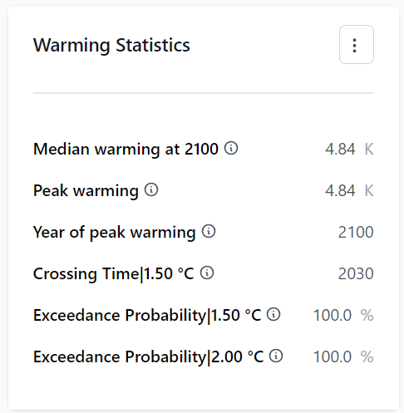

* The box tells you the year when global warming exceeds 1.5°C above pre-industrial temperatures. The UN Paris Agreement aims to keep global warming to below 1.5°C relative to pre-industrial, so this tells you whether that goal will be achieved or not. For this scenario, it is clear that the UN goal will be missed, as soon as 2030.
* This is not good news, but remember that this is a high greenhouse gas emissions scenario that we just ran. Next, we will do a simulation for a more optimistic scenario, which is a low greenhouse gas emissions scenario.

***Now we will run the low emissions scenario (SSP1-1.9)***

* Click on “**Scenarios**” at the top left of the page, to return to the **Scenarios Dashboard** of MAGICC:



* Click on “**Add Scenario**”:



* Download the template for the SSP1-1.9 scenario by clicking on “**Download template**” and selecting “**SSP1-1.9**” from the menu.
* This will download a file called “**rcmip_ssp119_template.csv**”. This is the template input file that we will use to run the climate model for the low emissions scenario.
* Copy the file you just downloaded to the **TEMPLATES** folder you created earlier.
* Rename the file “**SSP1-1.9_templ**”.
* Open the file by double-clicking on it (it should open in Excel).
* Use Excel to plot a graph of fossil and industrial CO2 emissions for both the SSP1-1.9 scenario and the SSP5-8.5 scenario you did earlier. You will find it easier to do the plot if you **copy the CO2 emissions data for each scenario into a new Excel** file and create the graph in that new Excel file (you should not edit the files you downloaded).
* This should allow you to compare the CO2 emissions for the two scenarios, like this:

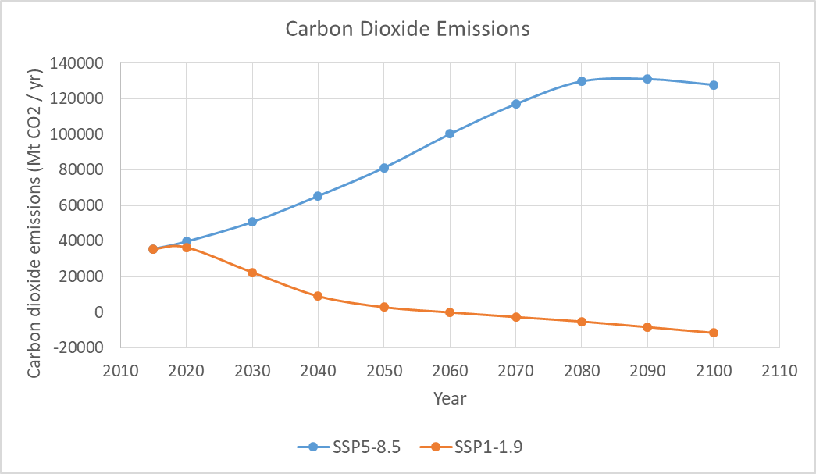

* We will now run the climate model with the input data for low greenhouse gas emissions (SSP1-1.9).
* On the **Create New Scenario** pageofMAGICC, type “SSP1-1.9 - Standard Setup” into the box below “Scenario Name”.
* You can leave the boxes next to “Notes” and “Tags” blank.
* Scroll down the page to where you see the “Emissions” section.
* Click on the folder icon with the plus sign in it.
* A window will open, prompting you to select a file. Navigate to the folder called TEMPLATES where you saved the SSP1-1.9 file. Click on the file and then “Open”.
* Scroll down to the section of the **Create New Scenario** pageofMAGICC where you see “MAGICC Setup”.
* In the MAGICC Setup box, select “**Custom**” from the drop-down menu.
* Don’t change any of the model settings.
* Click on “Run scenario” at the bottom of the page to run the climate model.

***Now we will compare the two climate model simulations***

* Click on “**Scenarios**” to return to the **Scenarios Dashboard** of MAGICC:



* You should see the two simulations you have done so far:



* In the **Scenarios Dashboard** we can plot graphs of the data produced from the simulations we have done.
* We will compare the greenhouse gas concentrations as well as global average Surface Temperature, for the high (**SSP5-8.5**) and low (**SSP1-1.9**) emissions scenarios.
* Click on “**Compare**” at the top of the page:



* This will open the **Compare Scenarios** **page**.
* Click on “Scenarios Selected” at the top right of the page:



* In the drop-down menu, select the two simulations you have done:

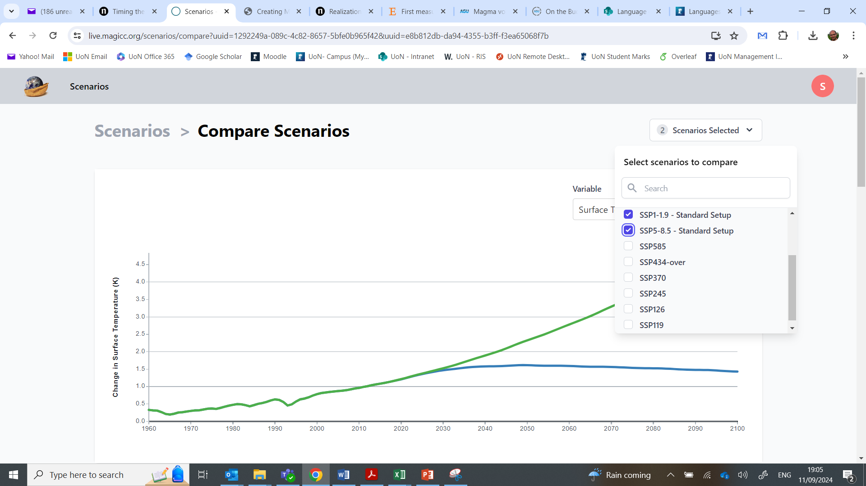

* Select “**Atmospheric Concentrations | CO2**” from the dropdown menu in the **Compare Scenarios** **page**:

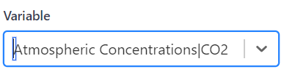

* The graph of CO2 concentrations for the two scenarios should look like this.

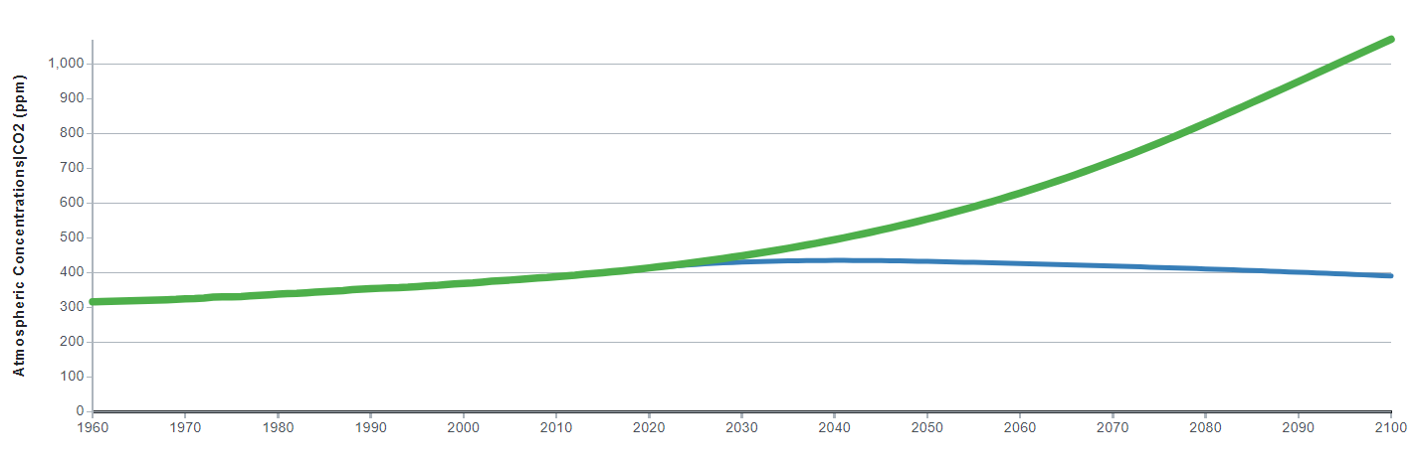

* Plot a graph of the Surface Temperature. It should look this this – you will see that the climate simulated by the model when the low emissions scenario is used as input, is much cooler than when the model is run with the high emissions scenario:

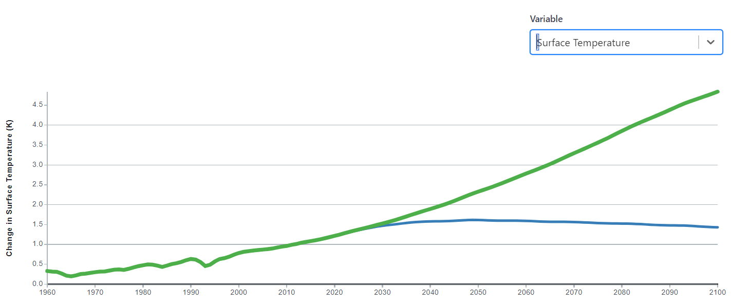

* You will see from the graph that with the low emissions scenario, the 1.5°C goal of the Paris Agreement is achieved. Therefore, from a climate policy decision-making perspective, it would be sensible to aim for the greenhouse gas emissions levels that are included in the SSP1-1.9 scenario if the world wants to achieve the goal of the Paris Agreement.

1. **The effects of number of ocean layers on simulation results**

* You will recall that in one of the lectures we said that climate models have improved over time in many ways, one of which is the number of vertical layers or levels that are used to represent the ocean and atmosphere respectively, e.g.:

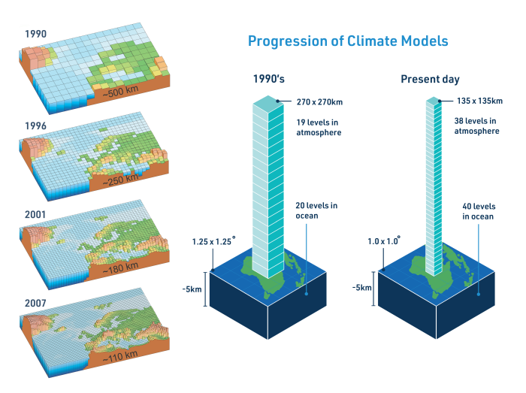

Source: <https://climateextremes.org.au/what-does-climate-model-resolution-mean/>

* MAGICC uses 50 layers for the ocean as a default.
* In this part of the practical, we will test the sensitivity of the climate model to the number of ocean layers that are included in the model.
* The simulations we did earlier both had 50 layers for the ocean in the model.
* We will now do a simulation for SSP5-8.5 **with just 10 layers**, to see if it make a difference to the simulated climate.

***Running a climate model simulation with 10 ocean layers instead of 50 layers***

* Click on “**Scenarios**” to return to the **Scenarios Dashboard** of MAGICC:



* Click on “Add Scenario”:
* This will take you to the **Create New Scenario** page.
* Type “**SSP5-8.5 - Reduced Ocean Layers to 10**” into the box below “**Scenario Name**”.
* You can leave the boxes next to “Notes” and “Tags” blank.
* Scroll down the page to where you see the “**Emissions**” section.
* Click on the folder icon with the plus sign in it.
* A window will open, prompting you to select a file. Navigate to the folder called **TEMPLATES** where you saved the SSP5-8.5 file. Click on the file “SSP5-8.5_templ.csv” and then “Open”.
* Scroll down to the section of the **Create New Scenario** pageofMAGICC where you see “**MAGICC Setup**”. This is where you can alter some of the features of the climate model, like how many layers the ocean in the model has.
* In the MAGICC Setup box, select “Custom” from the drop-down menu:



* This will make available a series of model options that can be changed with sliders or by inputting numbers into a box.
* Change the number of ocean layers from 50 to 10:

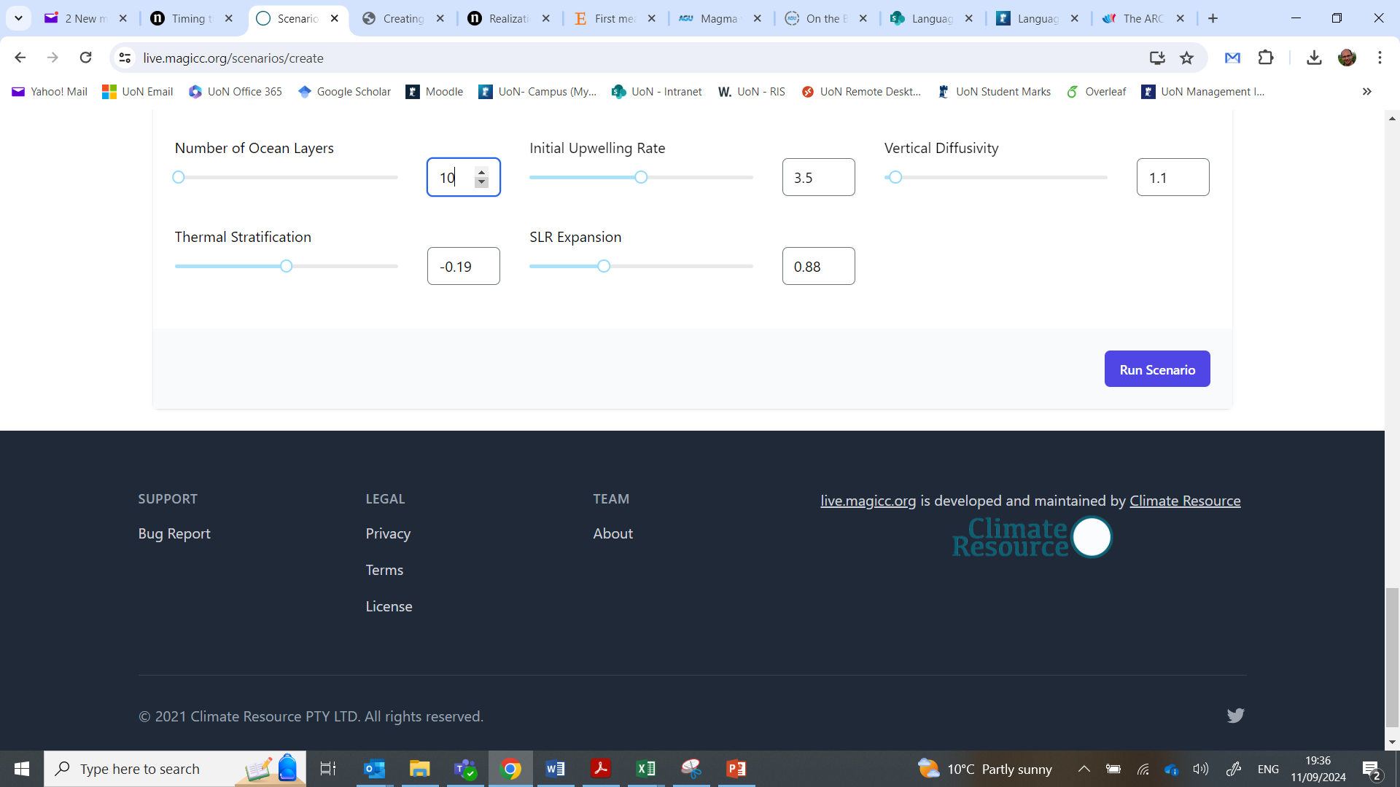

* Click on “Run scenario” at the bottom of the page to run the climate model.

***Comparing the simulation with 10 ocean layers to the 50 layers simulation***

* Click on “**Scenarios**” to return to the **Scenarios Dashboard** of MAGICC:



* You should see the three simulations you have done so far.
* Click on “Compare” at the top of the page.



* This will open the **Compare Scenarios** **page**.
* Click on “**Scenarios Selected**” at the top right of the page.
* In the drop-down menu, select the “SSP5-8.5 – Standard Setup” and “SSP5-8.5 - Reduced Ocean Layers to 10” simulations.
* The select “**Surface Temperature**” from the dropdown menu in the **Compare Scenarios** **page**.
* This should create a graph that looks like this – you can hover the mouse over the graph to see how different the global average temperature is in each simulation.

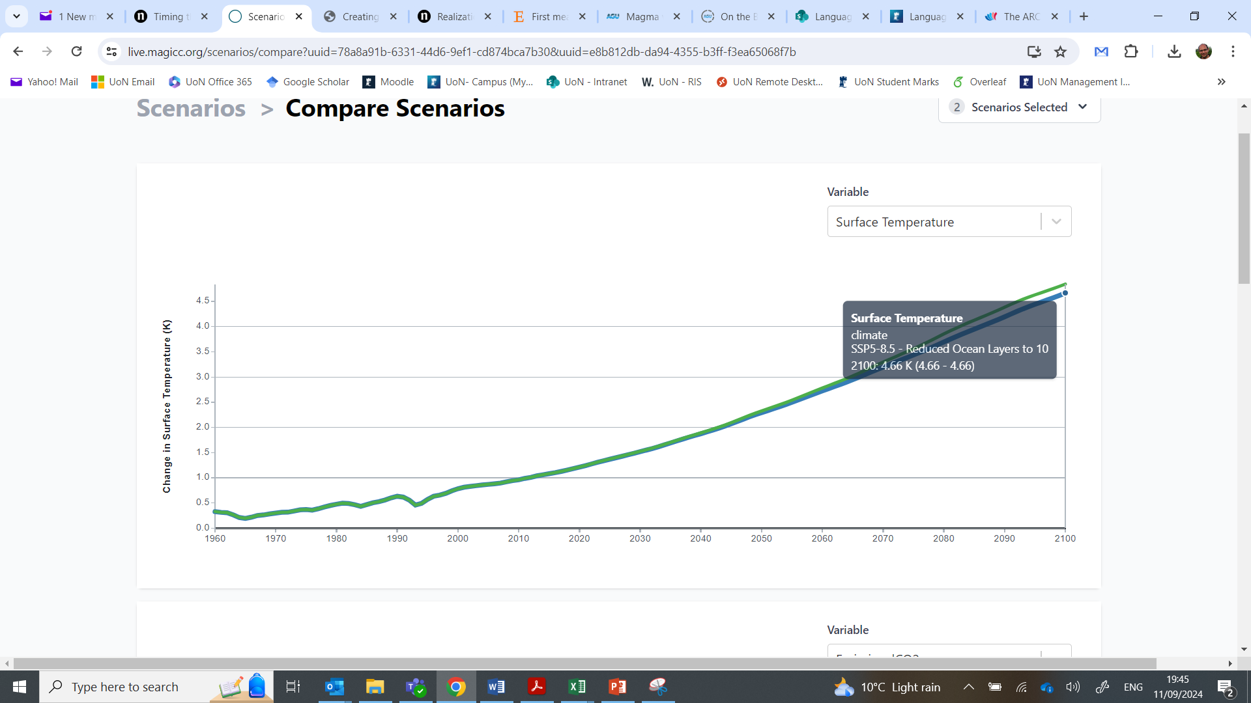

* You will see that when the climate model was run with 10 ocean layers it simulated a global mean surface temperature that is 0.18°C cooler than when the climate model was run with 50 layers. The difference between the two simulations is only due to the number of layers in the ocean because we used the same input file for the model in both simulations (the SSP5-8.5 emissions file).
* This shows that choices and decisions on how you setup your model can affect the results. A difference in global average temperature of 0.18°C is not small. However, if you create a plot of Surface Temperature for all three simulations that you have done so far, you will see that the climate simulated by the model is more sensitive to the greenhouse gas emissions than it is to choices on number of layers in the ocean – this is because there is a larger difference in temperature between the SSP5-8.5 and SSP1-1.9 scenarios, than there is between the 10 layer and 50 layer simulations:

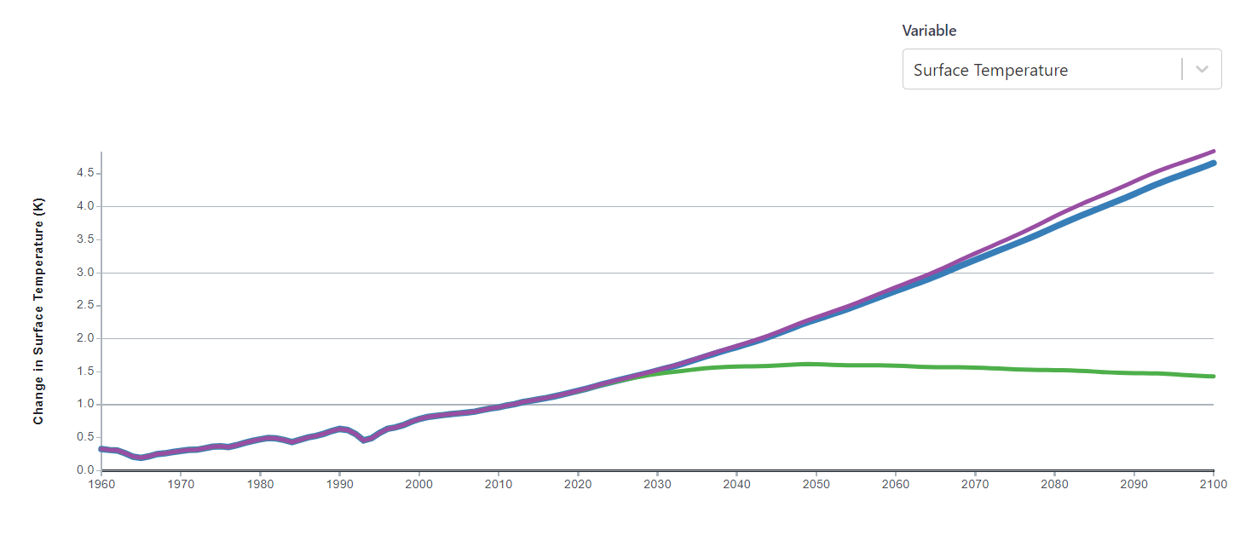

1. **Simulating the effect of volcanoes on global average surface temperature**

* In one of the lectures we talked about how volcanoes act as an internal forcing to the climate system. Whilst increases in greenhouse gases can act as a positive forcing on the climate system and cause a warming effect, volcanoes can act as a negative forcing because they can have a cooling effect.
* In this part of the practical we will simulate the effect of volcanoes on global mean temperatures, by conducting some experiments similar to the paper by Robock and Liu (1994) that we covered in one of the lectures:



Source: Robock & Liu (1994)

***Creating a MAGICC input file with annual forcings for SSP5-8.5***

* In the earlier stages of the practical, the input files we used for MAGICC, which included the greenhouse gas forcings, specified greenhouse gas emissions at **10-year intervals**.
* You can see this by opening the file called “SSP5-8.5_templ.csv” that is saved in your TEMPLATES folder. The years are specified as 2015, 2020, 2030, 2040 etc.



* It is okay in a reduced complexity model to specify the forcings every 10 years like this. However, if we want to simulate the effect of a volcanic eruption, then it would be better to provide forcings to the climate model on an **annual basis**, since volcanic eruptions are relatively short events that occur at a shorter timescale than every 10 years.
* Therefore, we will create a **new input file** for MAGICC that specifies greenhouse gas emissions **for every year**.
* We will base the new file on the SSP5-8.5 greenhouse gas emissions that we used earlier in the practical.
* Go to the **TEMPLATES** folder where you located your MAGICC input files for the SSP5-8.5 and SSP1-1.9 scenarios.
* Open the file **SSP5-8.5_templ.csv** in Excel.
* Now save the file as “**SSP5-8.5_ANN_templ**”.
* **In Excel, you need to modify the file so that it now includes annual data for every year from 2020 to 2100 inclusive**. The jump from 2015 to 2020 should still appear in the file, i.e. the annual data only needs to occur from 2020 onwards. This means that the top 3 rows of the file would look like this, with the years going up to 2100 in annual increments (the following steps will explain how to do this, if you are not sure how to do it):



* Start by inserting 9 new columns in-between each 10-year period (right-click on one of the letters at the top of a column and select “Insert”). This will give you 9 empty columns between 2020 and 2030, then 9 more empty columns between 2030 and 2040 etc.
* You can then use linear interpolation to fill in the data for the blank cells between each 10-year period. To do this, you need to highlight the cells between each 10-year period, e.g. highlight between 2020 and 2030 inclusive like below:

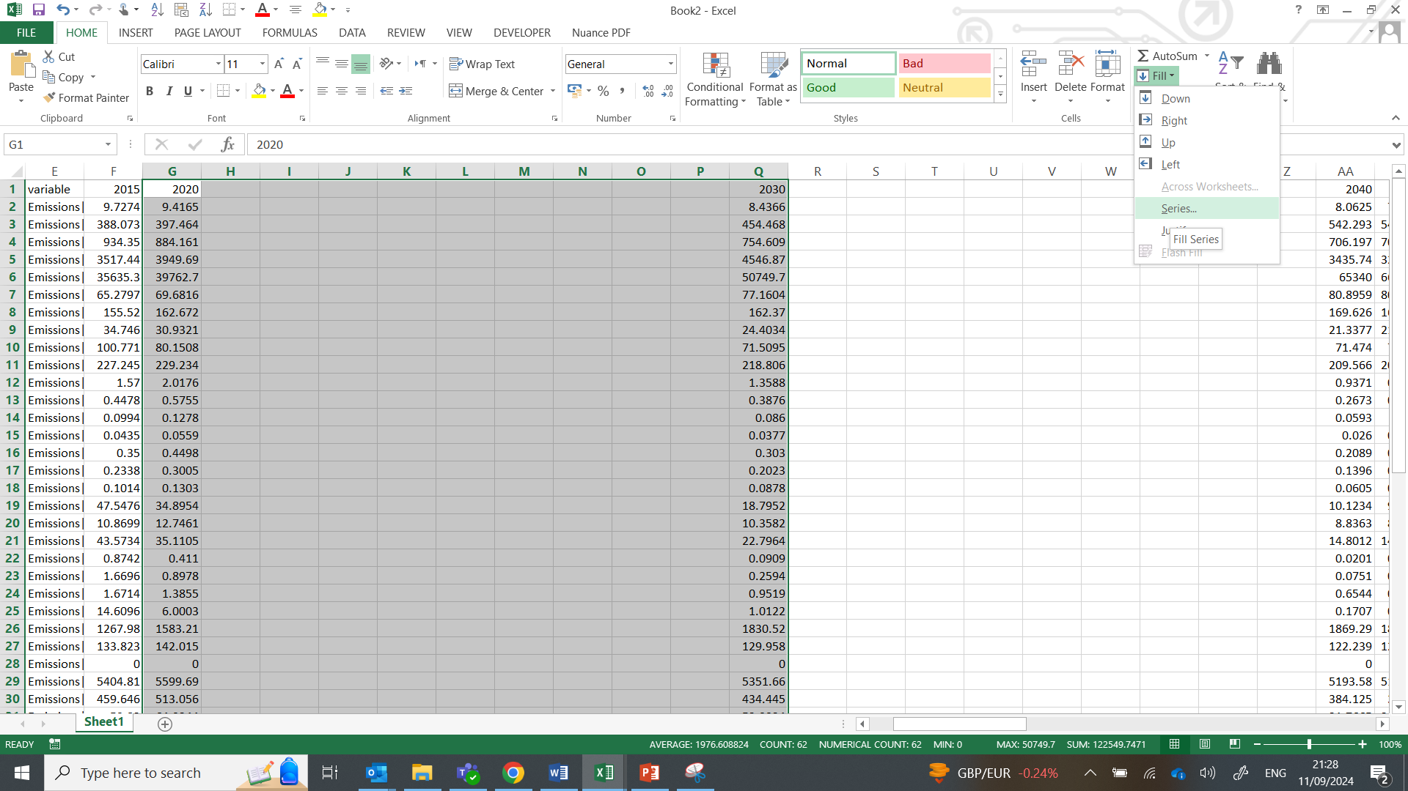

* Then with the cells highlighted, go to the **HOME tab** and click on **Fill > Series** (like in the screenshot above).
* Then select “**Rows**”, “**Linear**” and tick the box next to “**Trend**”. Then click “**OK**”:

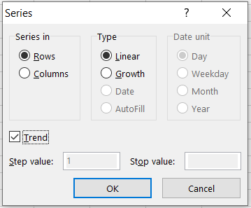

* This will fill in the missing data between the years by linear interpolation. Repeat this for each 10-year period.
* The top three rows should have numbers like this – **ask for help if you get stuck**:



***Run MAGICC with the annual forcings for SSP5-8.5***

* Before we simulate the effects of any volcanoes, we will first do a climate simulation with the annual forcings input file we just created. **This will be our control simulation**.
* On the **Scenarios Dashboard**, click on “**Add Scenario**”, which will take you to the **Create New Scenario** pageofMAGICC.
* On the **Create New Scenario** page, type “SSP5-8.5 - Annual” into the box below “Scenario Name”.
* You can leave the boxes next to “Notes” and “Tags” blank.
* Scroll down the page to where you see the “**Emissions**” section.
* Click on the folder icon with the plus sign in it.
* A window will open, prompting you to select a file. Navigate to the folder called TEMPLATES where you saved the “**SSP5-8.5_ANN_templ.csv**” file. Click on the file and then “Open”.
* Scroll down to the section of the **Create New Scenario** pageofMAGICC where you see “**MAGICC Setup**”.
* In the MAGICC Setup box, select “**Custom**” from the drop-down menu.
* Don’t change any of the model settings.
* Click on “**Run scenario**” at the bottom of the page to run the climate model:



* The climate model will now start running the SSP5-8.5 scenario using the annual emissions data you created.

***Run MAGICC with large volcanic eruptions in 2050 and 2080***

* We will now run a climate simulation in which there are large volcanic eruptions in 2050 and 2080.
* The magnitude of each volcano will be equivalent to past large eruptions seen in recent centuries. Specifically, we will assume that each eruption is similar to the **Tambora eruption that happened in 1815**.
* It is estimated that Tambora released up to 58 Mt (5.3–5.8 × 1013 g) of SO2 when it erupted (Self et al. 2004).
* We will model the effects on global average temperature of a Tambora-like eruption happening in 2050 and 2080 by **modifying the SO2 emissions** in the annual SSP5-8.5 file we created earlier.
* Open the **SSP5-8.5_ANN_templ.csv** file that you created earlier.
* Save the file as a different name, call it “**SSP5-8.5_ANN_Vol_templ.csv**”.
* Go to the column that corresponds to the year 2050 and the row for Sulfur emissions – this should be cell AK-10 in Excel, with a value of 60.442.
* To represent the additional SO2 emissions from a volcanic eruption in 2050 we need to add the emissions from a Tambora-like eruption to this year. Add 58 to the value in the cell AK-10; you should be putting 118.442 in the cell.
* Then do the same for Sulfur emissions in 2080, i.e. add 58 to the value in the appropriate cell. **Save the Excel file**.
* Go back to MAGICC. On the **Scenarios Dashboard**, click on “**Add Scenario**”, which will take you to the **Create New Scenario** pageofMAGICC.
* On the **Create New Scenario** page, type “**SSP5-8.5 – Annual - Volcanoes**” into the box below “**Scenario Name**”.
* You can leave the boxes next to “Notes” and “Tags” blank.
* Scroll down the page to where you see the “**Emissions**” section.
* Click on the folder icon with the plus sign in it.
* A window will open, prompting you to select a file. Navigate to the folder called TEMPLATES where you saved the “**SSP5-8.5_ANN_Vol_templ.csv**” file. Click on the file and then “Open”.
* Scroll down to the section of the **Create New Scenario** pageofMAGICC where you see “**MAGICC Setup**”.
* In the MAGICC Setup box, select “**Custom**” from the drop-down menu.
* Don’t change any of the model settings.
* Click on “**Run scenario**” at the bottom of the page to run the climate model:

* The graph of **Surface Temperatrue** produced by MAGICC should like this. Notice how the year-on-year global mean temperature increase relative to pre-industrial is **paused** in the years the volcanoes erupt. The model is simulating a relative cooling effect in 2050 and 2080 because of the volcanoes.

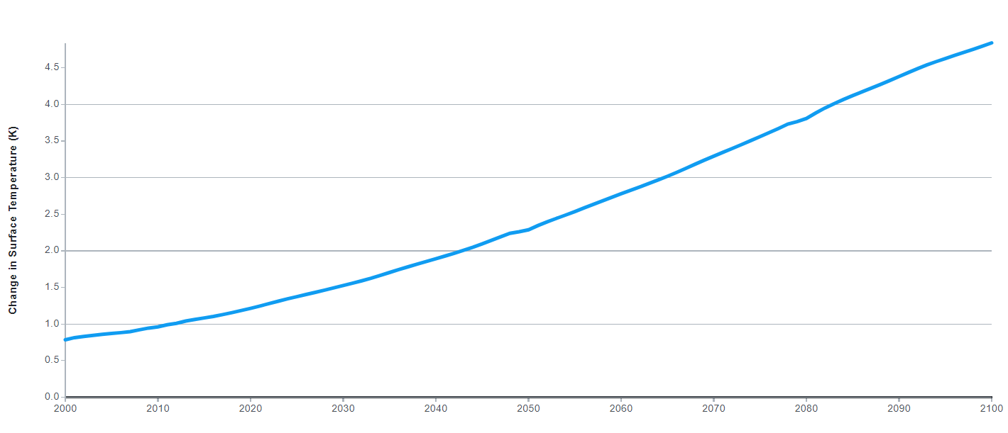

***Run MAGICC with a super-volcano eruption in 2050***

* We will now run a climate simulation in which there is one **super-volcano eruption in 2050**, to see how the effects of the eruption on the climate compare to the large eruptions we just simulated in 2050 and 2080.
* The magnitude of the super-volcano we will simulate, will be equivalent to an eruption that happened **74,000 years ago, at Mount Toba**.
* Whilst the mass of sulphur emitted from the Toba eruption is not fully known, it has been estimated that Toba could have released up to 3,000 Mt of SO2 when it erupted (Scaillet and Oppenheimer, 2024).
* We will model the effects on global average temperature of a Toba-like eruption happening in 2050 by modifying the SO2 emissions in the annual SSP5-8.5 file we created earlier.
* Open the **SSP5-8.5_ANN_templ.csv** file.
* Save the file as a different name, call it “**SSP5-8.5_ANN_Toba_templ.csv**”.
* Go to the column that corresponds to the year 2050 and the row for Sulfur emissions – this should be cell AK-10 in Excel, with a value of 60.442.
* To represent the additional SO2 emissions from a super-volcano eruption in 2050 we need to add the emissions from a Toba-like eruption to this year. Add 3000 to the value in the cell AK-10; you should be putting 3060.442 in the cell. **Save the Excel file**.
* Go back to MAGICC. On the **Scenarios Dashboard**, click on “**Add Scenario**”, which will take you to the **Create New Scenario** pageofMAGICC.
* On the **Create New Scenario** page, type “**SSP5-8.5 - Toba**” into the box below “**Scenario Name**”.
* You can leave the boxes next to “Notes” and “Tags” blank.
* Scroll down the page to where you see the “**Emissions**” section.
* Click on the folder icon with the plus sign in it.
* A window will open, prompting you to select a file. Navigate to the folder called TEMPLATES where you saved the “**SSP5-8.5_ANN_Toba_templ.csv**” file. Click on the file and then “Open”.
* Scroll down to the section of the **Create New Scenario** pageofMAGICC where you see “**MAGICC Setup**”.
* In the MAGICC Setup box, select “**Custom**” from the drop-down menu.
* Don’t change any of the model settings.
* Click on “**Run scenario**” at the bottom of the page to run the climate model:

***Analyse the effects of large volcanic eruptions and a super-volcano on global temperature***

* Click on “**Scenarios**” to return to the **Scenarios Dashboard** of MAGICC:



* You should see all the simulations you have done so far.
* Click on “Compare” at the top of the page.



* This will open the **Compare Scenarios** **page**.
* Click on “**Scenarios Selected**” at the top right of the page.
* In the drop-down menu, select the “**SSP5-8.5 - Annual**”, “**SSP5-8.5 – Annual - Volcanoes**” and “**SSP5-8.5 - Toba**”:

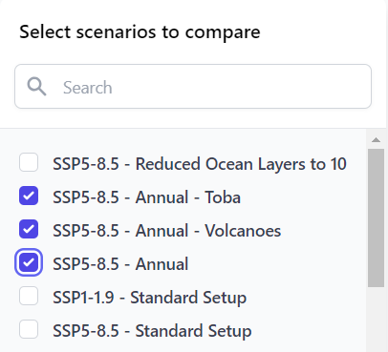

* The select “**Surface Temperature**” from the dropdown menu in the **Compare Scenarios** **page**.
* This should create a graph that looks like this:

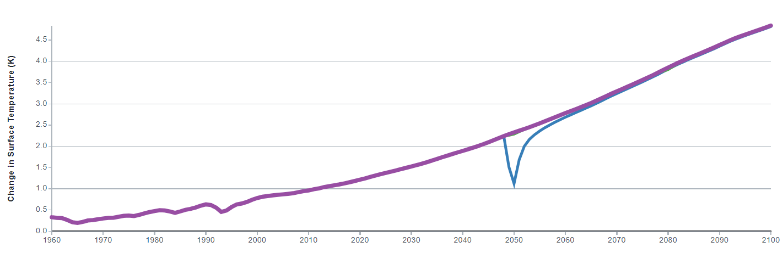

* You can see the significant effect that a super-volcano eruption has on global temperatures. There is abrupt and strong cooling, with the effects lasting for over a decade.

**End of Practical**

**References**

Meinshausen, M., Lewis, J., McGlade, C. et al. (2022) Realization of Paris Agreement pledges may limit warming just below 2 °C. *Nature* 604: 304–309. [https://doi.org/](https://doi.org/10.1038/s41586-022-04553-z)

Robock, A., Liu, Y. (1994) The Volcanic Signal in Goddard Institute for Space Studies Three-Dimensional Model Simulations. *Journal of Climate*, 7: 44–55. <http://www.jstor.org/stable/26197826>

Scaillet, B., Oppenheimer, C. (2024) On the budget and atmospheric fate of sulfur emissions from large volcanic eruptions. *Geophysical Research Letters*, 51: e2023GL107180. [doi.org/10.1029/2023GL107180](https://agupubs.onlinelibrary.wiley.com/doi/full/10.1029/2023GL107180)

Self, S., Gertisser, R., Thordarson, T., Rampino, M.R., Wolff J.A. (2004) Magma volume, volatile emissions, and stratospheric aerosols from the 1815 eruption of Tambora, *Geophysical Research Letters*, 31: L20608, [doi:10.1029/2004GL020925](https://agupubs.onlinelibrary.wiley.com/doi/full/10.1029/2004GL020925)